Part l. DDL – Database Structure

- CREATE DATABASE librarydb;

- CREATE TABLE authors (
author_id INT AUTO_INCREMENT PRIMARY KEY,
first_name VARCHAR(50) NOT NULL,
last_name VARCHAR(50) NOT NULL,
birth_year INT DEFAULT NULL CHECK (birth_year > 1900),
email VARCHAR(100) UNIQUE
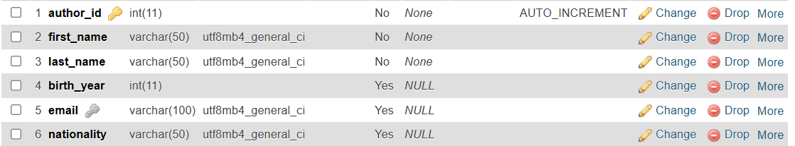
);

- CREATE TABLE books (
book_id INT PRIMARY KEY AUTO_INCREMENT,
title VARCHAR(50) NOT NULL UNIQUE,
published_year INT CHECK (published_year >= 1900),
pages INT DEFAULT 100 CHECK (page_count > 0),
author_id_fk INT NOT NULL,
FOREIGN KEY (author_id_fk) REFERENCES authors(author_id)
) ;

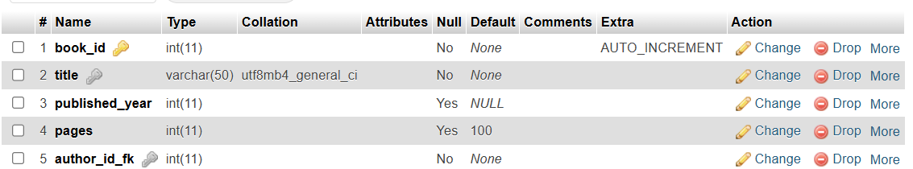
- ALTER TABLE authors
ADD nationality VARCHAR(50);
- ALTER TABLE books
CHANGE pages page_count INT;
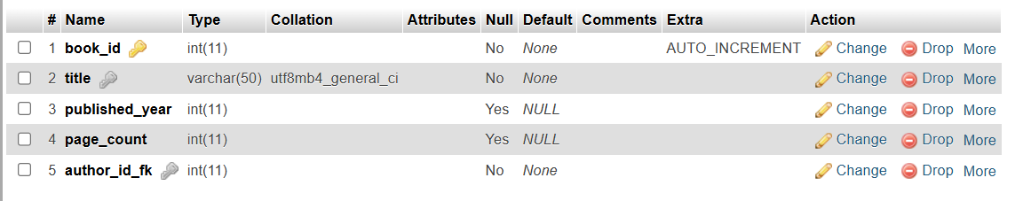
Part II. – Insert, Update, Delete
- INSERT INTO authors (first_name, last_name, birth_year, email) VALUES
('George', 'Orwell', 1903, 'gorwell@gmail.com'),
('J.K.', 'Rowling', 1965, 'jkrowling@gmail.com'),
('J.R.R.', 'Tolkien', 1892, 'jrrtolkien@gmail.com'),
('Harper', 'Lee', 1926, 'hlee@gmail.com'),
('F. Scott', 'Fitzgerald', 1896, 'fscott@gmail.com');

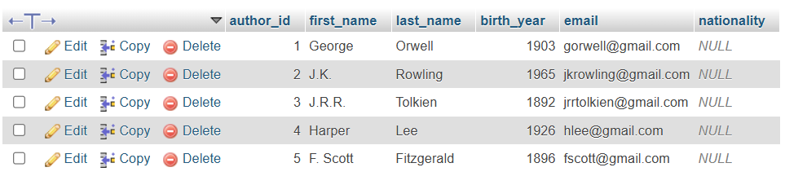
- INSERT INTO books (title, published_year, page_count, author_id_fk) VALUES
('Animal Farm', 1945, 328, 1),
('Harry Potter and the Sorcerer''s Stone', 1997, 309, 2),
('Harry Potter and the Goblet of Fire', 2000, 636, 2),
('The Hobbit', 1937, 310, 3),
('The Lord of the Rings', 1954, 1178, 3),
('To Kill a Mockingbird', 1960, 281, 4),
('Tender is the Night', 1934, 317, 5),
('The Great Gatsby', 1925, 180, 5),
('The Side of Paradise', 1920, 305, 5);
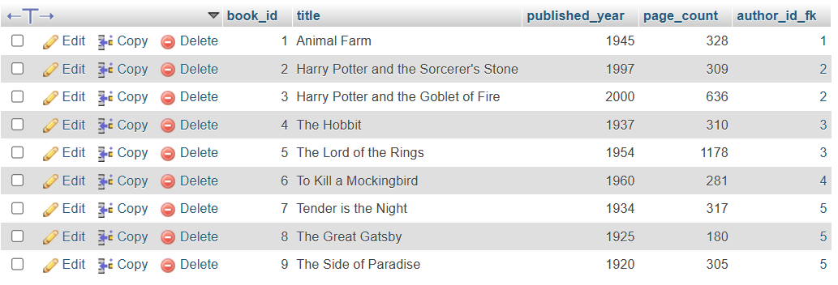

- UPDATE books
SET page_count = 320
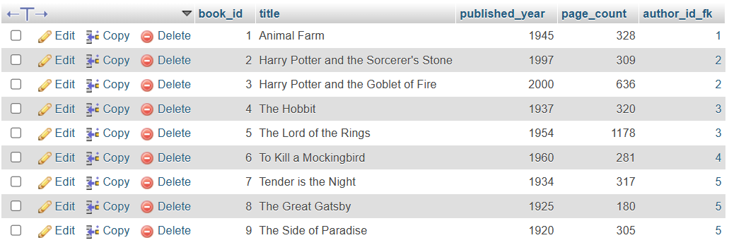
WHERE title = 'The Hobbit';

- DELETE FROM books
WHERE title = 'The Side of Paradise';
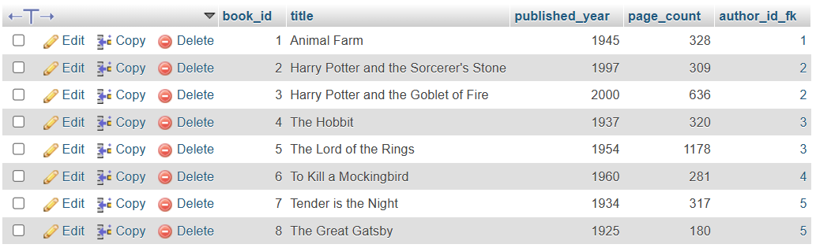
- INSERT INTO authors (first_name, last_name, birth_year, email)
VALUES ('Anna', 'Keating', 1965, 'annakt@gmail.com');
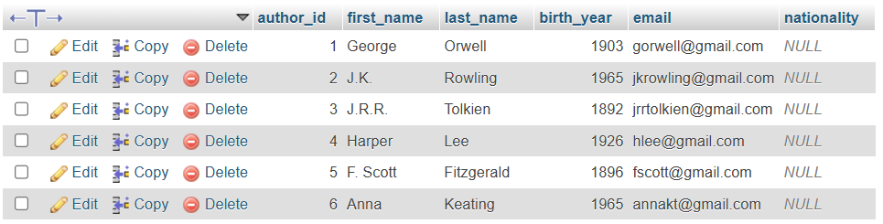

Part III. DML – Select and Filter
- SELECT * FROM authors;
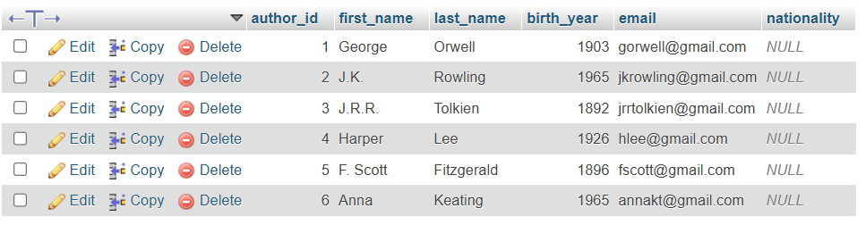
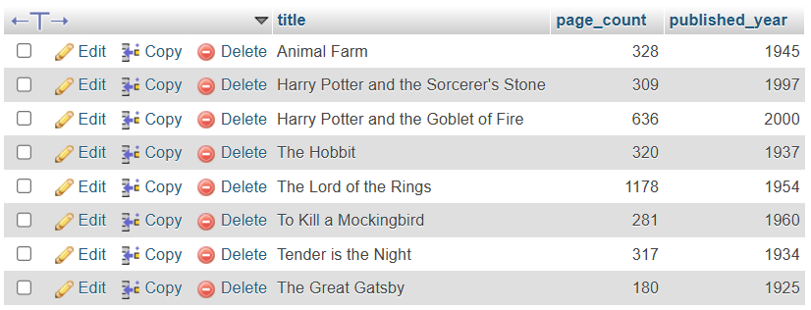
- SELECT title, page_count, published_year FROM books;

- SELECT * FROM authors
WHERE birth_year < 1950;
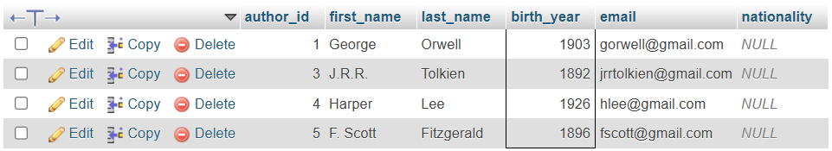

- SELECT * FROM books
WHERE published_year > 1950
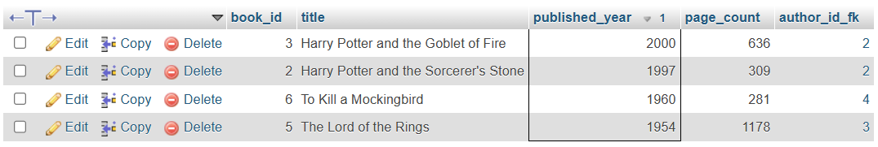
ORDER BY published_year DESC;

- SELECT * FROM books
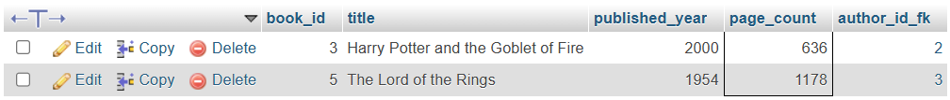
WHERE page_count > 500;

Part IV. Operates and Aggregates
- SELECT * FROM books
WHERE published_year > 1950 AND page_count > 300;
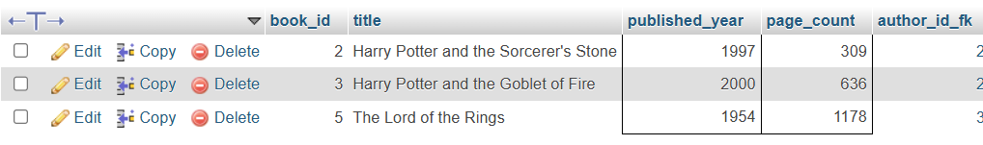
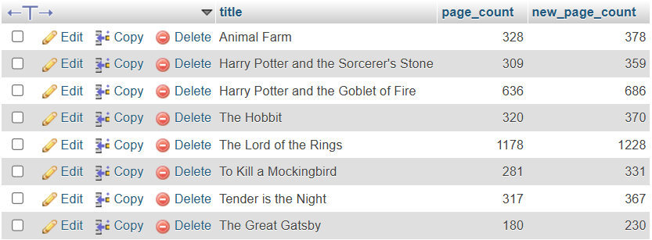
- SELECT title, page_count, (page_count + 50) AS new_page_count FROM books;

- SELECT
COUNT(*) AS total_books,
SUM(page_count) AS total_pages,
AVG(page_count) AS average_pages,
MIN(page_count) AS min_pages,
MAX(page_count) AS max_pages
FROM books;

- SELECT COUNT(book_id)
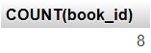
FROM books;

Part V. Joins
- SELECT
b.title,
CONCAT(a.first_name, ' ', a.last_name) AS author_name
FROM books b
JOIN authors a
ON b.author_id_fk = a.author_id;
